Sketch of home page

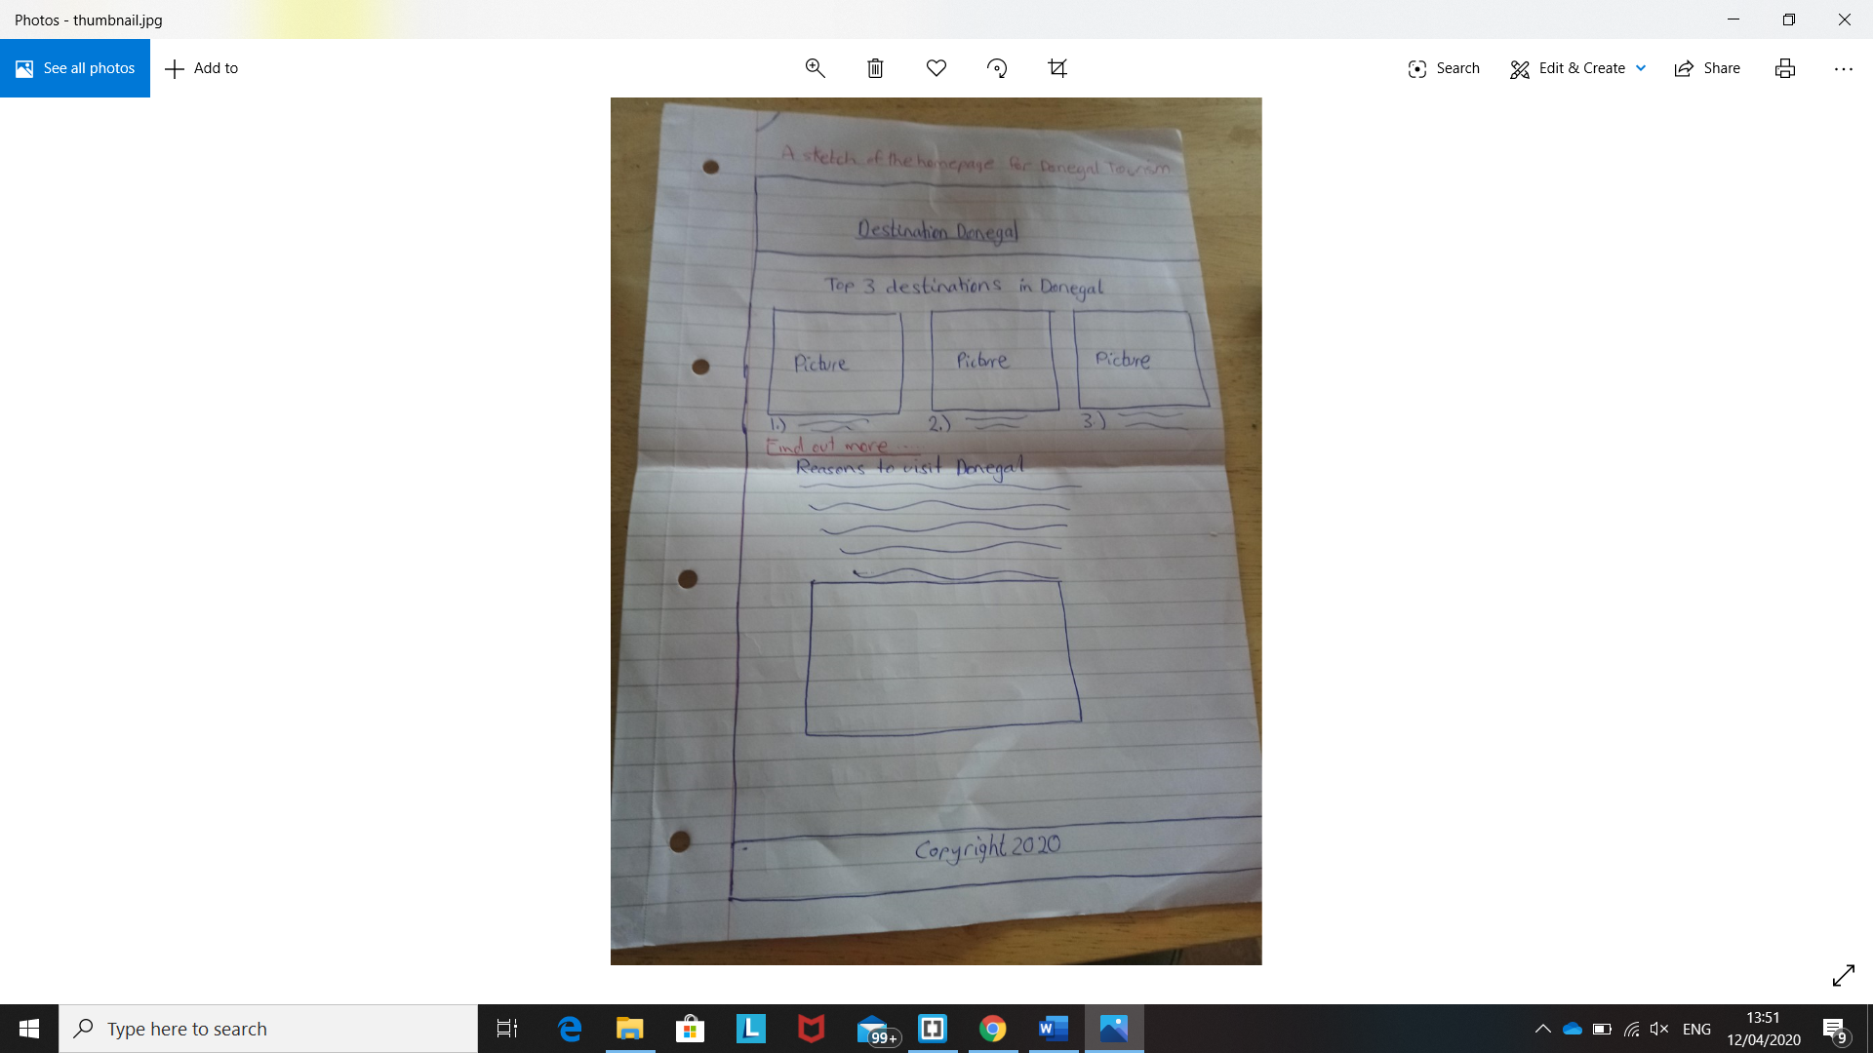

Summary of web pages

Page 1 contains a brief description about Donegal with a picture beside it. Below that there is a heading called Top Destinations in Donegal with 3 pictures going horizontal across the screen. Below that there is another brief description about Donegal Tourism. There is a nav above and below the screen to navigate between pages. There is a link above the bottom nav to go back up to the top.

Page 2 contains 3 separate descriptions about each attraction in a column format. This page follows the last with the same nav and the link to top.

Page 3 contains google map links and YouTube links for each attraction. This page follows the other 2 with the same nav and the link to the top.

Page 4 is the contact page. Details include first name, last name, email, gender, heard of us, and a query section.